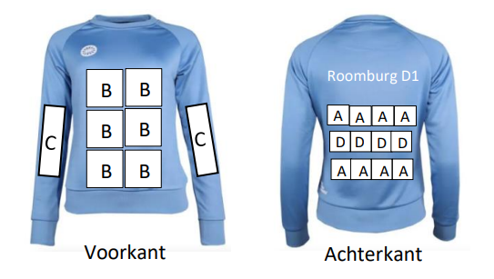

**Leidse Hockeyclub Roomburg D1**Van Vollenhovekade 20  
2313GG Leiden

INGNL47INGB0630628572R.E.A. den Boer

Trui sponsor

06-45661722  
fleurvanexel@gmail.com

Bank:  
IBAN:  
t.n.v.

Ovv:

Tel:  
E-mail:

Aan:

…

…

…

…

Factuur

|  |  |  |  |  |  |  |  |
| --- | --- | --- | --- | --- | --- | --- | --- |
| |  |  |  | | --- | --- | --- | | **Factuurnummer** | **Factuurdatum** | **Vervaldatum** | |  |  |  | |  |

|  |  |  |  |  |  |  |  |  |  |
| --- | --- | --- | --- | --- | --- | --- | --- | --- | --- |
| **OMSCHRIJVING** |  |  | | |  | |  | | **TOTAAL** |
|  | | | | |  | |  | |  |
|  | | | | | | | | | |
|  | | | | | | | | | |
|  | | |  |  | | **TOTAAL TE BETALEN** | |  | |